# Informações do estudo

Referência: Keblouti - uncoated insert

Grandeza: Força

Tipo: Fz

Material: AISI 52100

Ferramenta: CT5015 uncoated insert

Número de experimentos: 27

Observações:  
Universal lathe SN 40C type  
Workpiece: round bars66 mm of diameter and 380 mm cutting length.  
Dynamometer: KISTLER Type 9257A  
Roughnessmeter: Surftest 201 Mitutoyo

# Unidades

Velocidade: m/min

Avanço: mm/rev

Profundidade de corte: mm

Força: N

# Dados de teste

|  |  |  |  |
| --- | --- | --- | --- |
| Força | n | f | a |
| 69.75 | 250.0 | 0.08 | 0.15 |
| 225.57 | 200.0 | 0.16 | 0.45 |
| 138.04 | 150.0 | 0.12 | 0.3 |
| 148.22 | 150.0 | 0.08 | 0.45 |
| 88.73 | 200.0 | 0.12 | 0.15 |
| 98.54 | 200.0 | 0.08 | 0.3 |

# Dados de treino

|  |  |  |  |
| --- | --- | --- | --- |
| Força | n | f | a |
| 198.91 | 250.0 | 0.12 | 0.45 |
| 125.01 | 250.0 | 0.12 | 0.3 |
| 174.19 | 150.0 | 0.16 | 0.3 |
| 178.32 | 200.0 | 0.16 | 0.3 |
| 145.84 | 200.0 | 0.12 | 0.3 |
| 60.33 | 150.0 | 0.08 | 0.15 |
| 97.91 | 250.0 | 0.16 | 0.15 |
| 241.24 | 150.0 | 0.16 | 0.45 |
| 233.37 | 250.0 | 0.16 | 0.45 |
| 89.19 | 200.0 | 0.16 | 0.15 |
| 88.89 | 150.0 | 0.16 | 0.15 |
| 78.65 | 150.0 | 0.12 | 0.15 |
| 149.41 | 200.0 | 0.08 | 0.45 |
| 95.03 | 150.0 | 0.08 | 0.3 |
| 88.96 | 250.0 | 0.16 | 0.3 |
| 190.15 | 150.0 | 0.12 | 0.45 |
| 74.98 | 250.0 | 0.12 | 0.15 |
| 53.55 | 200.0 | 0.08 | 0.15 |
| 181.57 | 200.0 | 0.12 | 0.45 |
| 144.59 | 250.0 | 0.08 | 0.45 |
| 99.29 | 250.0 | 0.08 | 0.3 |

# RN

Número de neurônios: 99

Taxa de aprendizado: 1.000000e-02

Número de épocas: 16

2° camada: False

Função de ativação: tanh

# Erros

**Dados de teste**

* Erro relativo médio: 11.6
* Coeficiente de correlação: 0.98
* Coeficiente de determinação: 0.97
* MSE: 185.88
* RMSE: 13.63

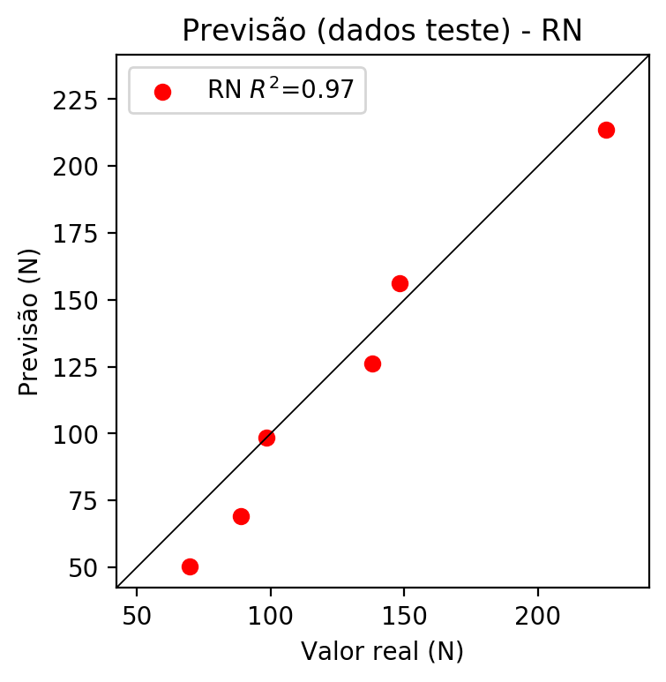

**Dados de treino**

* Erro relativo médio: 12.11
* Coeficiente de correlação: 0.93
* Coeficiente de determinação: 0.87
* MSE: 406.52
* RMSE: 20.16

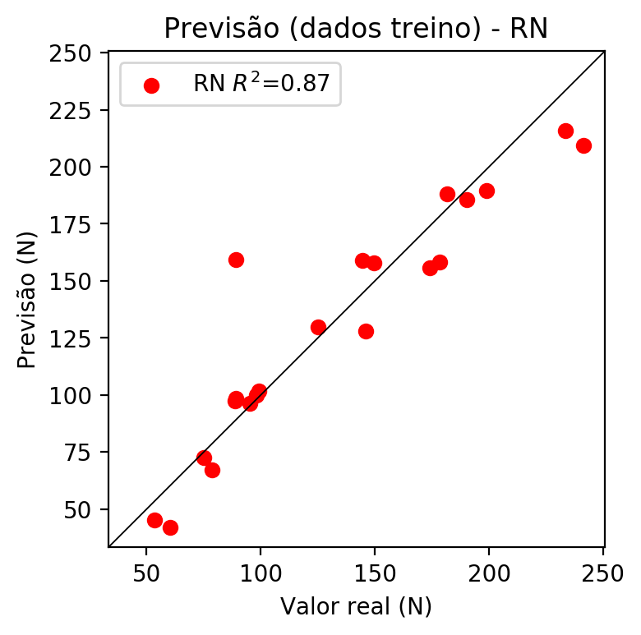

# Pesos

Pesos - camada oculta 1

[[ 0.0334367 -0.03791097 -0.04015632 -0.13757947 0.01524063 -0.00063816  
 0.13261352 0.07193092 0.02571136 -0.02513278 -0.1014105 0.03351223  
 -0.02764406 -0.01595188 0.00964217 0.01592231 -0.09697732 0.03063471  
 -0.07585859 0.07867376 0.07975142 0.04367367 0.03196261 0.00656644  
 0.09277742 -0.04471717 0.10746906 -0.03086485 0.05290249 -0.05116136  
 0.04340219 -0.11124713 -0.02055124 -0.06004152 -0.0865849 -0.04244079  
 -0.04546931 -0.00617183 -0.05323479 0.05556845 0.00041579 0.00093867  
 0.07408587 0.09100352 -0.01348704 0.046245 0.15365809 -0.02932305  
 0.07640311 0.11115275 0.02612318 0.03089961 -0.03597154 0.03768532  
 0.01026454 -0.03131075 0.0597401 -0.13891476 -0.09298444 -0.08439716  
 0.06714574 -0.07350414 -0.0718783 -0.03628968 0.10020576 -0.09668521  
 0.09832042 -0.02212311 -0.07805752 -0.01478554 0.09534324 -0.00661754  
 -0.08101444 -0.05070381 -0.01597794 -0.03878619 -0.02502464 0.06327467  
 -0.12383891 0.03111735 0.03837877 -0.10715451 -0.10640676 0.02446802  
 -0.01637433 0.06562872 0.1529637 -0.08569156 -0.1038512 0.06713536  
 0.02232321 -0.05720263 -0.11166421 -0.03780708 0.01592675 -0.03715992  
 -0.10437808 -0.0880317 -0.01657739]  
 [-0.0805333 0.20453808 -0.21457167 0.2545409 -0.09104641 -0.30382746  
 -0.24191013 0.01702757 -0.19965069 0.12561335 0.08012155 0.08255742  
 -0.06266911 0.11924525 0.12198677 -0.03675793 0.30312812 -0.07480738  
 -0.18163987 0.00672223 -0.06790978 0.13596496 -0.25490692 0.0978994  
 -0.1546216 0.16704182 0.10001378 0.29495558 0.02949185 -0.2991975  
 -0.16236092 0.04865539 -0.08207873 -0.06719306 0.10969195 0.13052905  
 0.22420743 -0.02858127 0.01188918 -0.26325613 0.27794746 -0.02181551  
 -0.15748732 0.11377726 0.03004621 -0.0708818 -0.11382023 0.14176163  
 0.20577139 0.28654572 0.16215852 0.2987202 -0.09678409 -0.09452316  
 -0.24890195 -0.06870568 -0.16421266 0.2163696 0.11878597 0.03523278  
 0.0639338 -0.24868022 0.0746895 -0.09085522 0.05731088 -0.27571297  
 -0.268138 0.2541826 -0.1874871 -0.30360147 -0.15721989 0.00679475  
 0.0672285 -0.30627856 0.2545677 -0.3059218 0.19105491 -0.15886927  
 0.20201707 -0.05221226 -0.15336613 0.17880891 0.08434717 0.03190144  
 -0.16691035 0.03925281 -0.1338626 0.12803122 0.14381124 0.05495848  
 -0.18218137 -0.09592886 -0.24862269 -0.00795206 -0.05880162 0.02354924  
 -0.15595429 0.23463748 0.19418767]  
 [ 0.02342461 0.04576895 0.05469388 -0.05946766 0.3429605 -0.03578646  
 -0.24003111 -0.13422382 -0.18469667 0.05025203 -0.13374685 0.2894829  
 0.1401301 -0.10846498 -0.29060662 0.00286895 0.25452363 -0.03223987  
 -0.01785726 0.23639715 0.31266493 0.2131235 0.0771045 0.20956045  
 -0.21623656 0.01309901 0.2596596 -0.05098668 0.09460176 -0.22736421  
 0.00315242 -0.31269026 -0.33329684 -0.23732966 0.05203287 -0.3322373  
 0.30169585 0.22739267 -0.21487795 -0.18756866 0.34347314 0.00657977  
 0.18419538 0.08008372 0.18511336 -0.10799217 -0.07079961 0.03804205  
 0.15124832 0.10258336 0.14830565 0.1426738 0.24463893 -0.21851201  
 0.09727766 -0.0551382 0.09962656 0.2828335 0.06806785 -0.05300527  
 0.23920117 -0.28225508 -0.2838514 0.2893269 0.10247605 -0.25824967  
 -0.3121223 0.07057901 -0.18648392 -0.22595368 -0.35033387 0.09871585  
 0.09819995 -0.06854355 -0.07798626 -0.35492286 0.02784446 0.14218293  
 0.23711863 -0.1386626 0.01485982 -0.16181673 -0.1438548 0.12593387  
 -0.29303822 -0.00059055 -0.11553923 0.10544944 -0.04929295 0.13997884  
 -0.09534825 -0.07460321 -0.13013971 0.2742143 -0.28210565 0.00963592  
 0.05214244 0.38008004 0.05362813]]

Bias - camada oculta

[-0.0447595 -0.00318808 -0.05529651 0.08129208 0.02396877 -0.04120868  
 0.04859462 -0.0534727 0.0150067 0.0001556 0.037283 -0.00865818  
 -0.00697673 0.04554253 -0.02416833 0.01415199 -0.06111501 0.00908195  
 -0.04706641 -0.00377047 0.00472046 0.0010005 -0.00326842 -0.00459239  
 0.0261236 0.07155665 0.00471125 0.01507432 -0.00850189 -0.00041903  
 0.00523052 0.00158323 0.01520462 0.00100639 -0.00622252 -0.02344529  
 -0.04967627 0.00333747 0.0043085 0.02856384 -0.0636686 -0.02772938  
 -0.02813 0.02041526 -0.00275871 0.00539872 -0.0324425 0.06878528  
 0.03151121 0.07001075 0.00982797 0.0251168 0.00910617 0.01006888  
 -0.04655332 -0.03887616 -0.08994027 -0.06012947 0.08095261 0.03694348  
 -0.00071453 0.01076651 -0.00173493 0.01786258 -0.00018789 -0.01186502  
 0.0791138 0.01043494 -0.02071906 0.01909115 0.0651839 -0.02096518  
 0.05280708 -0.05859732 0.04105563 0.06432837 0.00958249 -0.03713942  
 -0.03566211 0.0066534 -0.06201908 0.04843618 0.03726031 0.04013748  
 0.02526816 -0.01386188 -0.01903383 0.08706739 0.06822459 -0.00039599  
 -0.00228011 -0.01029505 -0.05747025 0.0040379 0.00749515 0.03607312  
 -0.04640942 -0.09188743 0.0128235 ]

Pesos - camada saída

[[ 4.23724651e-02 -2.61295997e-02 -3.63251157e-02 1.67813912e-01  
 3.00182328e-02 1.56407878e-02 -1.69919044e-01 -7.59011656e-02  
 2.78048851e-02 -2.62580160e-02 -1.09597377e-01 3.72923464e-02  
 -1.33200865e-02 2.37680804e-02 -9.63271689e-03 1.21658649e-02  
 1.91425622e-01 2.86578927e-02 -7.51247481e-02 8.47704709e-02  
 8.86847377e-02 4.41936441e-02 5.42961694e-02 9.64199658e-03  
 -1.14826016e-01 -5.59697375e-02 1.10350095e-01 -6.49786517e-02  
 5.78749739e-02 -4.20869067e-02 -6.55379705e-03 -1.18909240e-01  
 -2.53540613e-02 -6.39537573e-02 7.31742457e-02 -5.57728857e-02  
 4.16585095e-02 6.07496407e-03 -6.03877306e-02 -2.90258564e-02  
 -1.45750456e-02 7.97224790e-03 8.52650329e-02 9.31644216e-02  
 -4.50659916e-03 -3.57132852e-02 -1.60057172e-01 -4.00220901e-02  
 7.44755939e-02 1.07462384e-01 2.45818682e-02 2.00176984e-02  
 -7.90439360e-03 4.90216259e-03 2.30020396e-02 -3.31401080e-02  
 -3.68822776e-02 1.65896878e-01 -1.01714849e-01 -9.12409052e-02  
 7.11697340e-02 -6.89981654e-02 -8.11429992e-02 -3.89820314e-03  
 1.04355425e-01 -9.21246707e-02 -2.01368332e-01 -3.87551785e-02  
 -7.69535899e-02 -2.39433721e-05 -1.65243790e-01 7.60884490e-03  
 7.54661262e-02 -4.21071872e-02 -3.11519802e-02 -2.70367060e-02  
 -3.37424390e-02 7.46286586e-02 1.88130230e-01 2.02717893e-02  
 4.95885238e-02 -1.17809251e-01 -1.14673465e-01 4.20244113e-02  
 -1.50153795e-02 6.99316785e-02 -1.60661340e-01 -9.46286321e-02  
 -1.13380708e-01 7.12660775e-02 2.76706368e-02 -5.94924539e-02  
 -1.09400108e-01 -6.48488873e-04 4.32593375e-03 -4.37116176e-02  
 -1.05409324e-01 2.22537383e-01 -2.40144245e-02]]

# Iterações

|  |  |  |  |  |  |  |
| --- | --- | --- | --- | --- | --- | --- |
| Média | Desvio | n | ln | 2° camada | Função | Épocas |
| -0.3701 | 0.254 | 10 | 0.1 | False | relu | 38 |
| -0.3891 | 0.3385 | 17 | 0.1 | True | relu | 716 |
| -0.3224 | 0.2559 | 7 | 0.01 | True | tanh | 130 |
| -0.2175 | 0.1923 | 19 | 0.001 | False | tanh | 282 |
| -0.2244 | 0.176 | 29 | 0.001 | False | relu | 469 |
| -0.5645 | 0.0577 | 88 | 0.1 | False | tanh | 926 |
| -0.3307 | 0.1833 | 95 | 0.0001 | True | relu | 984 |
| -0.3396 | 0.3383 | 10 | 0.01 | True | tanh | 865 |
| -0.6848 | 0.4301 | 58 | 0.001 | True | relu | 8 |
| -0.3983 | 0.2218 | 9 | 0.01 | False | tanh | 514 |
| -0.2853 | 0.1176 | 73 | 0.0001 | True | relu | 729 |
| -0.2982 | 0.1541 | 22 | 0.001 | True | relu | 543 |
| -0.5152 | 0.232 | 25 | 0.1 | True | relu | 562 |
| -0.2346 | 0.1686 | 53 | 0.001 | False | relu | 498 |
| -0.3355 | 0.1412 | 83 | 0.01 | True | relu | 337 |
| -0.1999 | 0.1866 | 99 | 0.01 | False | tanh | 16 |
| -0.5686 | 0.2036 | 23 | 0.01 | False | relu | 472 |
| -0.3228 | 0.1461 | 24 | 0.001 | True | relu | 778 |
| -0.3986 | 0.119 | 58 | 0.01 | True | tanh | 382 |
| -0.5573 | 0.1953 | 35 | 0.1 | False | tanh | 596 |

# RL

# Coeficientes

[ 0. -0.11614942 0.4174911 0.90111048]

# Erros

**Dados de teste**

* Erro relativo médio: 15.46
* Coeficiente de correlação: 0.96
* Coeficiente de determinação: 0.93
* MSE: 348.51
* RMSE: 18.67

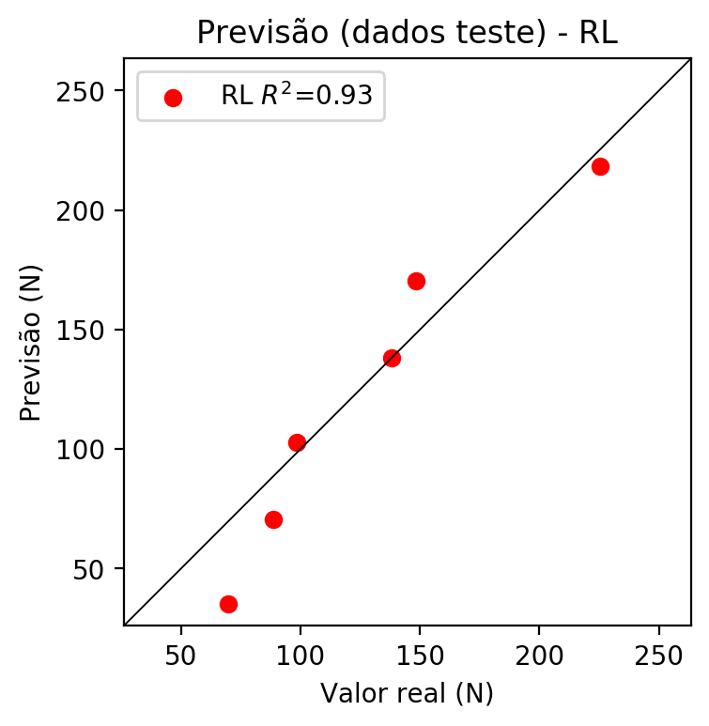

**Dados de treino**

* Erro relativo médio: 12.24
* Coeficiente de correlação: 0.94
* Coeficiente de determinação: 0.89
* MSE: 333.12
* RMSE: 18.25

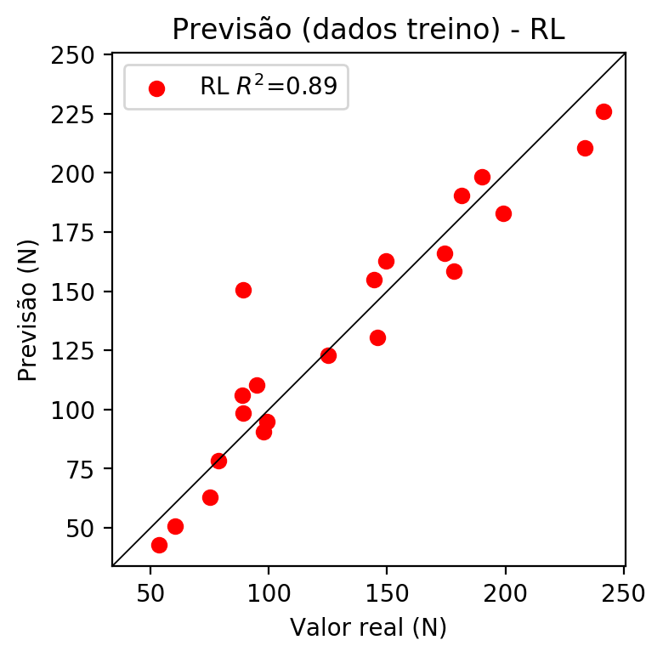

# RP2

# Coeficientes

[ 0. -0.06098451 0.43931502 0.85603124 -0.07915865 -0.10089749  
 -0.00114682 -0.06195303 0.18772539 0.09008436]

# Erros

**Dados de teste**

* Erro relativo médio: 5.41
* Coeficiente de correlação: 1.0
* Coeficiente de determinação: 0.99
* MSE: 56.57
* RMSE: 7.52

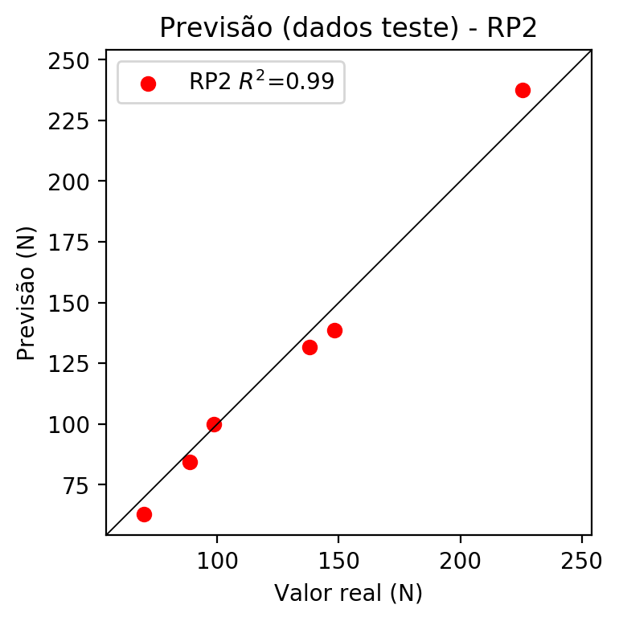

**Dados de treino**

* Erro relativo médio: 9.23
* Coeficiente de correlação: 0.96
* Coeficiente de determinação: 0.93
* MSE: 225.72
* RMSE: 15.02

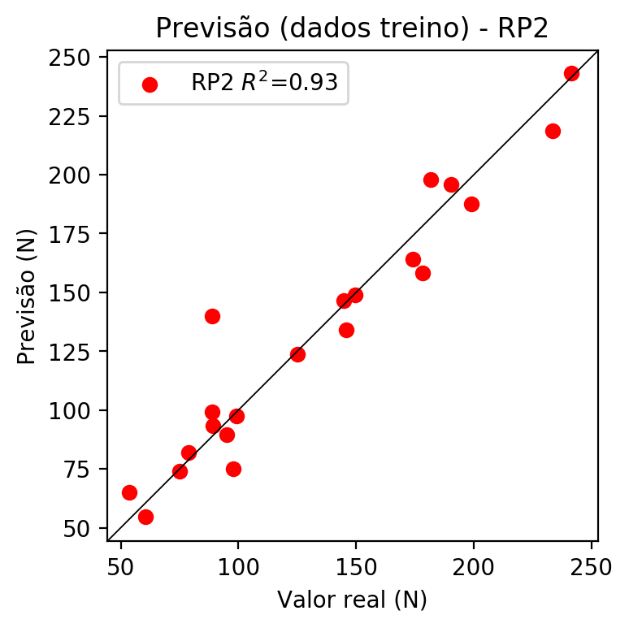

# RP3

# Coeficientes

[ 0. -0.08621643 0.13528923 0.29257125 -0.13188452 -0.14509828  
 0.03649765 -0.09114849 0.25444425 0.04945284 -0.12453485 -0.06563851  
 -0.0729239 0.00584849 -0.07333462 0.22982862 0.19541777 0.00570969  
 0.13313129 0.42260292]

# Erros

**Dados de teste**

* Erro relativo médio: 12.02
* Coeficiente de correlação: 0.93
* Coeficiente de determinação: 0.87
* MSE: 612.48
* RMSE: 24.75

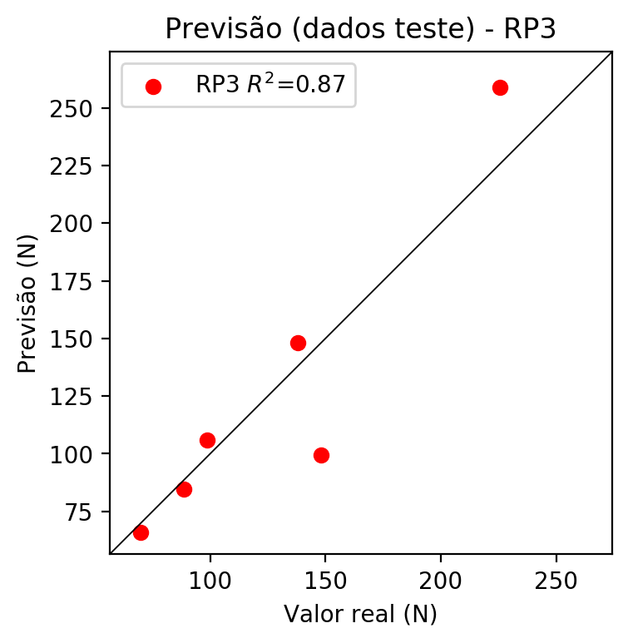

**Dados de treino**

* Erro relativo médio: 7.74
* Coeficiente de correlação: 0.98
* Coeficiente de determinação: 0.96
* MSE: 127.72
* RMSE: 11.3

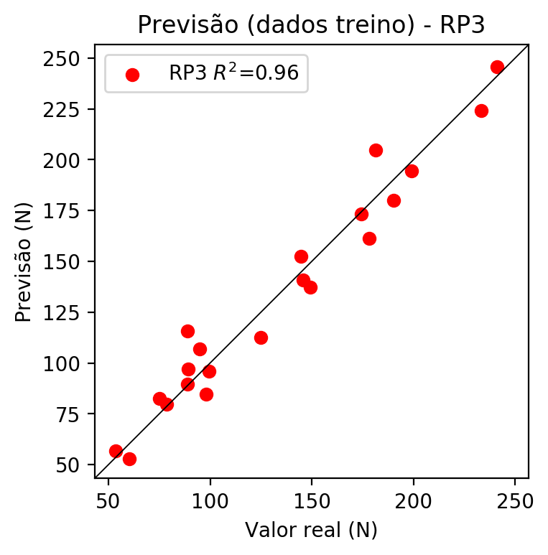

# RP4

# Coeficientes

[-0.19499482 0.06775314 0.16975323 0.21909073 -0.38183671 0.07390134  
 -0.14762968 0.03132213 0.04740006 -0.10049494 -0.09199916 -0.14173468  
 0.00786985 -0.16563972 0.02073961 0.0583404 0.20335047 0.13498105  
 0.10551273 0.45318309 0.12143899 -0.072072 0.05625483 -0.14406487  
 -0.19929906 0.24862079 -0.17288085 -0.08074879 0.32307891 0.07286747  
 -0.00732469 0.09915991 0.14994979 0.06844147 -0.12420866]

# Erros

**Dados de teste**

* Erro relativo médio: 32.37
* Coeficiente de correlação: 0.95
* Coeficiente de determinação: 0.9
* MSE: 1915.1
* RMSE: 43.76

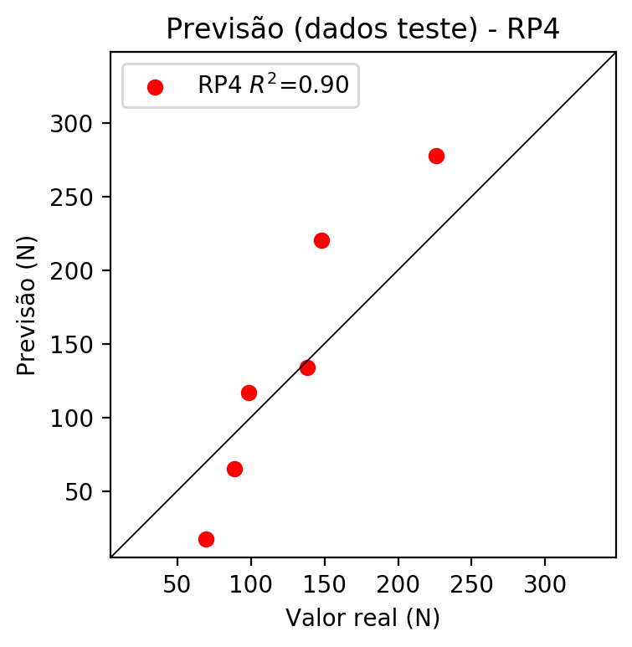

**Dados de treino**

* Erro relativo médio: 0.0
* Coeficiente de correlação: 1.0
* Coeficiente de determinação: 1.0
* MSE: 0.0
* RMSE: 0.0

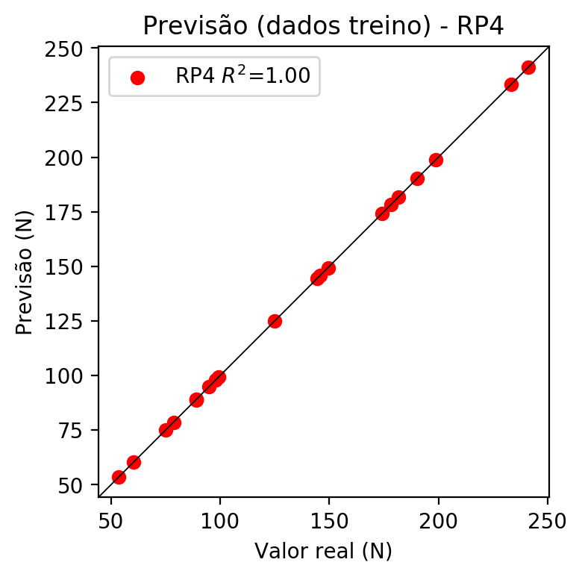

# Geral

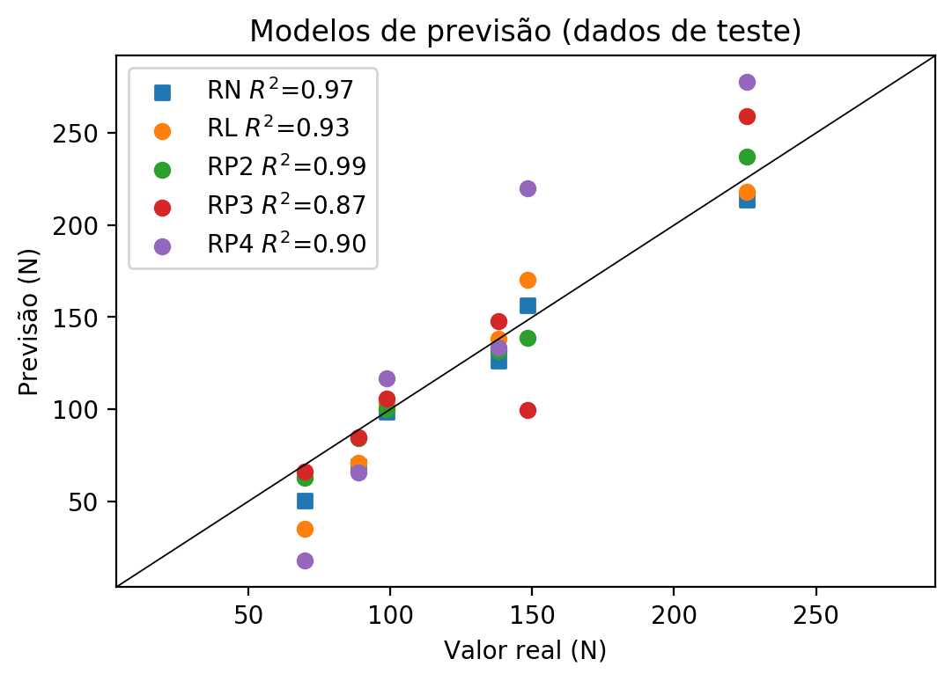

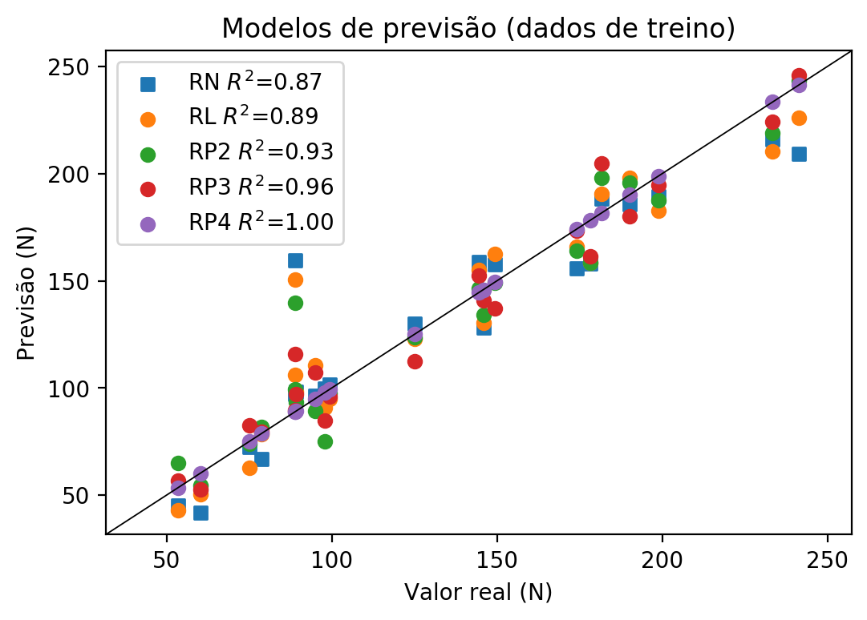

**Dados de teste**

|  |  |  |  |  |  |  |  |  |  |  |
| --- | --- | --- | --- | --- | --- | --- | --- | --- | --- | --- |
| Valor real | RN Previsto | RN Erro (%) | RL Previsto | RL Erro (%) | RP2 Previsto | RP2 Erro (%) | RP3 Previsto | RP3 Erro (%) | RP4 Previsto | RP4 Erro (%) |
| 69.75 | 50.43 | 27.7 | 35.14 | 49.62 | 62.87 | 9.86 | 66.01 | 5.36 | 17.61 | 74.75 |
| 225.57 | 213.63 | 5.29 | 218.24 | 3.25 | 237.38 | 5.24 | 258.97 | 14.81 | 277.6 | 23.07 |
| 138.04 | 126.08 | 8.66 | 138.28 | 0.17 | 131.71 | 4.59 | 147.97 | 7.19 | 133.67 | 3.17 |
| 148.22 | 156.34 | 5.48 | 170.44 | 14.99 | 138.69 | 6.43 | 99.45 | 32.9 | 220.13 | 48.52 |
| 88.73 | 68.97 | 22.27 | 70.63 | 20.4 | 84.25 | 5.05 | 84.72 | 4.52 | 65.37 | 26.33 |
| 98.54 | 98.37 | 0.17 | 102.79 | 4.31 | 99.82 | 1.3 | 105.76 | 7.33 | 116.68 | 18.41 |

**Dados de treino**

|  |  |  |  |  |  |  |  |  |  |  |
| --- | --- | --- | --- | --- | --- | --- | --- | --- | --- | --- |
| Valor real | RN Previsto | RN Erro (%) | RL Previsto | RL Erro (%) | RP2 Previsto | RP2 Erro (%) | RP3 Previsto | RP3 Erro (%) | RP4 Previsto | RP4 Erro (%) |
| 198.91 | 189.52 | 4.72 | 182.75 | 8.12 | 187.64 | 5.67 | 194.57 | 2.18 | 198.91 | 0.0 |
| 125.01 | 129.98 | 3.98 | 122.83 | 1.74 | 123.6 | 1.13 | 112.58 | 9.94 | 125.01 | 0.0 |
| 174.19 | 155.73 | 10.6 | 166.04 | 4.68 | 164.04 | 5.83 | 173.18 | 0.58 | 174.19 | 0.0 |
| 178.32 | 158.13 | 11.32 | 158.32 | 11.22 | 158.25 | 11.26 | 161.3 | 9.54 | 178.32 | 0.0 |
| 145.84 | 127.98 | 12.25 | 130.55 | 10.48 | 133.98 | 8.13 | 140.81 | 3.45 | 145.84 | 0.0 |
| 60.33 | 41.85 | 30.63 | 50.59 | 16.14 | 54.66 | 9.4 | 52.85 | 12.4 | 60.33 | 0.0 |
| 97.91 | 99.79 | 1.92 | 90.67 | 7.39 | 75.16 | 23.24 | 84.73 | 13.46 | 97.91 | 0.0 |
| 241.24 | 209.39 | 13.2 | 225.96 | 6.33 | 243.26 | 0.84 | 245.9 | 1.93 | 241.24 | 0.0 |
| 233.37 | 215.82 | 7.52 | 210.52 | 9.79 | 218.84 | 6.23 | 224.34 | 3.87 | 233.37 | 0.0 |
| 89.19 | 98.33 | 10.25 | 98.39 | 10.32 | 93.51 | 4.84 | 97.1 | 8.87 | 89.19 | 0.0 |
| 88.89 | 97.31 | 9.47 | 106.11 | 19.37 | 99.22 | 11.62 | 89.79 | 1.01 | 88.89 | 0.0 |
| 78.65 | 66.98 | 14.84 | 78.35 | 0.38 | 81.89 | 4.12 | 79.72 | 1.36 | 78.65 | 0.0 |
| 149.41 | 157.72 | 5.56 | 162.71 | 8.9 | 148.94 | 0.31 | 137.19 | 8.18 | 149.41 | 0.0 |
| 95.03 | 96.28 | 1.32 | 110.51 | 16.29 | 89.48 | 5.84 | 107.06 | 12.66 | 95.03 | 0.0 |
| 88.96 | 159.5 | 79.29 | 150.59 | 69.28 | 139.8 | 57.15 | 115.72 | 30.08 | 88.96 | 0.0 |
| 190.15 | 185.52 | 2.43 | 198.2 | 4.23 | 195.93 | 3.04 | 179.97 | 5.35 | 190.15 | 0.0 |
| 74.98 | 72.42 | 3.41 | 62.9 | 16.11 | 73.96 | 1.36 | 82.64 | 10.22 | 74.98 | 0.0 |
| 53.55 | 45.13 | 15.72 | 42.86 | 19.96 | 65.09 | 21.55 | 56.66 | 5.81 | 53.55 | 0.0 |
| 181.57 | 188.21 | 3.66 | 190.48 | 4.91 | 198.11 | 9.11 | 204.82 | 12.8 | 181.57 | 0.0 |
| 144.59 | 158.86 | 9.87 | 154.99 | 7.19 | 146.53 | 1.34 | 152.45 | 5.44 | 144.59 | 0.0 |
| 99.29 | 101.63 | 2.36 | 95.06 | 4.26 | 97.5 | 1.8 | 95.99 | 3.32 | 99.29 | 0.0 |